DAVENPORT HOUSE SURGERY
Dr C Thenuwara  Dr R Yasotharan  Dr A Bagga  Dr M Choudhuri  Dr H Kirsop  Dr K Nowlan  Dr I Lomax | 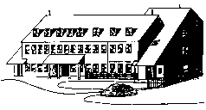 | Bowers Way  Harpenden  Herts  AL5 4HX  Tel: 01582-767821  www.davenportsurgery.co.uk  Practice Manager: Mr A Mehta

Patient complaint form
SECTION 1: PATIENT DETAILS

Surname |  | Title
Forename |  | Address
Date of birth
Telephone no. |  | Postcode

SECTION 2: COMPLAINT DETAILS

Please give full details of the complaint below including dates, times, locations and names of any organisation staff (if known). Continue a separate page if required.

SECTION 3: OUTCOME

SECTION 4: SIGNATURE
Surname & initials |  | Title
Signature |  | Date
SECTION 5: ACTIONS

Passed to management Yes/No

